Historical context:
It’s not an exaggeration to say that post apostolic age, Luther is possibly the single most consequential figure in the history of the Church (Augustine might be in the running as well). I’ll give you a secular reference. Around the year 2000, A&E polled various academics and put out a list of the most influential people of the millennium. Martin Luther was number three on the list. Johann Gutenberg was number one, and Isaac Newton was number two. It’s hard to argue against Gutenberg, but I think you could easily make a case for Martin to be even higher on the list.

I find it useful to situate myself on the timeline of history, so let’s talk for a minute about some of the historical context.

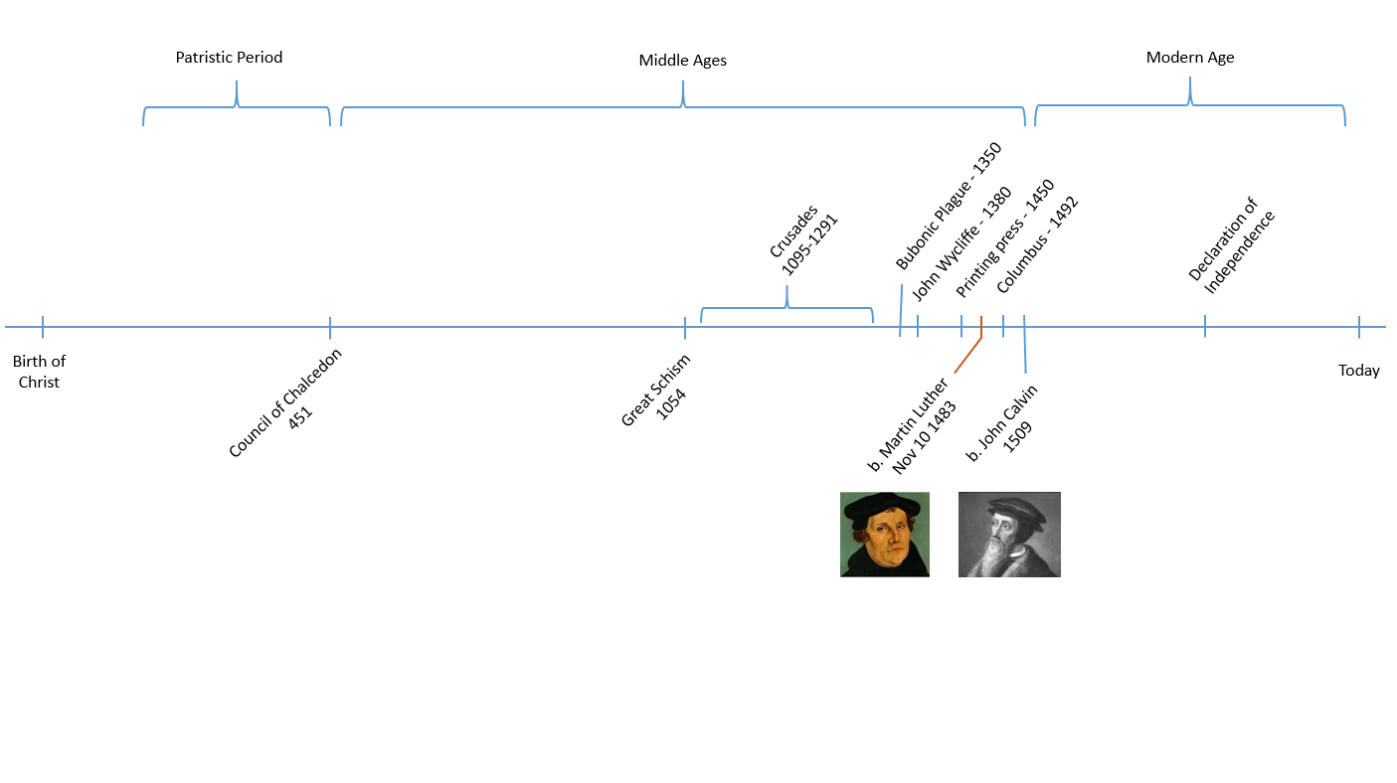

Martin Luther was born on November 10, 1483 in Eisleben, Germany. This was about a thousand years after the end of the Patristic period, which Phil taught us about a month ago. We’ll name just a couple of events that were particularly significant for the events that we’re going to talk about tonight.

1054 - In 1054 there was a schism in the Church, primarily over the issue of Papal supremacy. It is known in history as the Great Schism. The Church splits into the Western Church, centered in Rome, and the Eastern church, now known as the Eastern Orthodox Church, centered in Constantinople.

1095 - 1291 - The Crusades. The Western church sought to reclaim the Holy Land from the Muslims.

1350 - Bubonic plague. Half of the population of Europe died in a four year period. Luther’s separation from the plague is comparable to our separation from the Civil War. Think about how much the war affects our consciousness now. Imagine if half of all men, women and children had died in the Civil War.

1380 - John Wycliffe translates the Bible into English

1455 - Along comes Gutenberg and changes everything. Gutenberg prints the Bible on his removable type printing press. This was a total game changer, and was critical for the spread of Luther’s ideas. The reformation doesn’t happen without the printing press.

1492 - Christopher Columbus. Luther was 9 years old when Columbus sailed the ocean blue.

1509 - Calvin born. Calvin is a 2nd generation reformer, and building upon what Luther started.

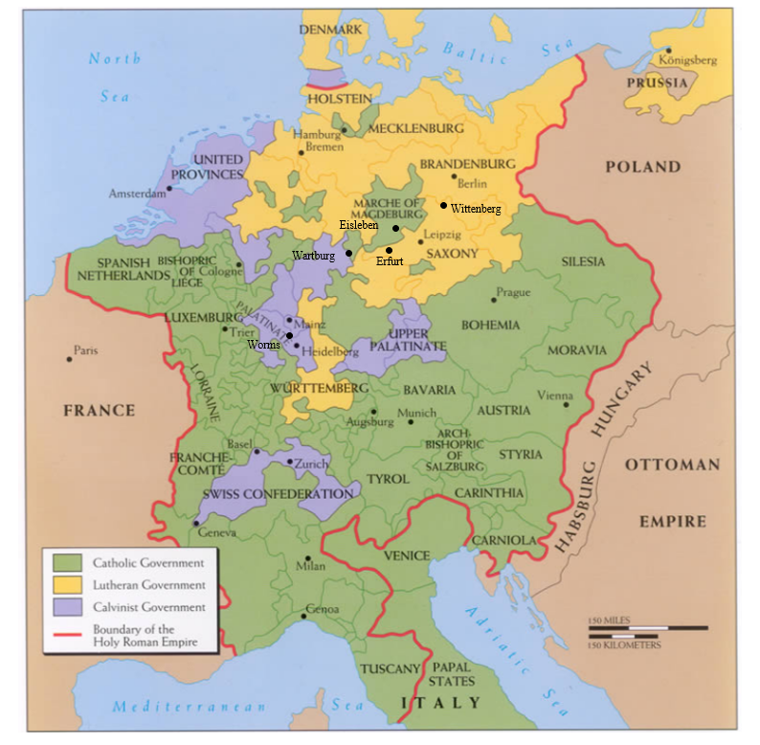

At this time Germany was not a sovereign nation, but was part of the Holy Roman Empire, under the authority of the emperor. The emperor during the time of this story was Charles V.
The empire was split into states, and governed locally by prince electors who, as the name suggests, elect the emperor and submit to his authority. Wittenberg, where Luther spent most of his life, is in the state of Saxony. The Prince Elector there was a man named Frederick the Wise, who is important to the story of Martin Luther.

After the great schism of 1054, the religious world was split between the east and west. “The church,” for Luther and those of his day, meant the Roman Catholic church, under the authority of the bishop of Rome, also known as the Pope. The Roman church was the only game in town, and the Pope’s authority was vast. He had not just absolute religious authority, but tremendous political authority as well. The Pope and the emperor were always in tension, with each of the vying for more power, both political and religious.

Childhood:
Martin’s father was Hans Luther, and his mother was Margaretta. Hans was a miner, and an entrepreneur, who over time came to own several mines and foundries. Soon after Martin was born, Hans moved with his family to Mansfeld to pursue his mining career.

Luther came from a devout peasant family, but there are elements of his religious upbringing that would seem odd to us. For instance, Luther’s world is one where devils and demons are physically present and active. It’s the kind of world where the woods are inhabited by elves & fairies. Remembering this helps to make some sense of Luther’s later writings. For example, Luther has no trouble whatsoever with the notion that the devil is real and physically active in this world, almost to the point that it can make us slightly uncomfortable. But I think this is one of many things that Luther has to teach us.

All in all, there was nothing unique about his upbringing. His parents sent Luther to school. His father wanted him to become a lawyer and support his parents in their old age. In 1501, and the age of 17, Luther began his studies at the university at Erfurt, with the intention of becoming a lawyer.

The vow:
Luther’s first watershed moment happened in July, 1505. He was on his way back to the university at Erfurt when he was caught in a tremendous thunderstorm. The rain was pouring down, the lightning was crashing around him, and Luther feared for his life. In desperation he cried out, “St Anne, help me! I will become a monk.” The cry may seem odd until we remember that St. Anne is the patroness saint of miners. This was likely not the first time that Martin had cried to her for help. Luther took his vow seriously, and two weeks later he admitted himself at the Augustinian cloister there in Erfurt. This all seems very rash, but this was also likely not the first time that Martin had entertained the thought of monastic life. Luther had a category, as did many men of his day, for the monastery as the place where people go to set themselves right with God. And as we will see, how to be set right with God was an all consuming thought.

Luther’s father was irate. He had hoped for a great law career from his son. Some have placed a great deal of significance on this strain that this placed on Luther’s relationship with his father, but we shouldn’t make too much of all that.

The cloister:
Let’s talk for a minute about the theological world that Luther was brought up in, his starting point from which the theology that we associate with the Reformation would take shape. Luther’s conception of God is characteristic of the time, and reflects the teaching of the church. God sits on his throne in heaven. He looks down on us and is angry with what he sees. He is, above all else, a God who punishes sinners.

“The entire training of home, school, and university was designed to instill fear of God and reverence for the Church” (HIS, p20)

The salvation that the Church taught was largely a works based salvation. Their doctrine on this is confusing, but they said, essentially, God’s grace comes to those who do their best. The old latin maxim is, “To the one who does that which is within him, God will not deny grace.”

Grace, for them, was an objective thing, something that could be measured out and distributed. The way that grace comes to you, they said, is through the sacraments, and there were sacraments for every phase of life, from birth, to marriage, to death. The primary ones were baptism, the mass, and penance. Baptism takes care of your original sin, and any sins committed up until that point. But of course you keep on sinning. And the way that those sins are forgiven is through the mass, which we’ll discuss more later, and through penance - that is confessing your sins. If you are sufficiently contrite, penance will get you back into a state of grace and keep you out of hell. But in addition to penance, certain works of righteousness are required to get you into heaven. And the standard that you’re held to is not fixed, it depends on the capability that you have within you.

So God gives grace to those who do their best. But Luther’s problem is this: how do you know when you’ve done your best? How do you know when you are sufficiently contrite? He spent hours confessing his sin, and going back again if an unconfessed sin came to mind. But there are always sins that you don’t know about.

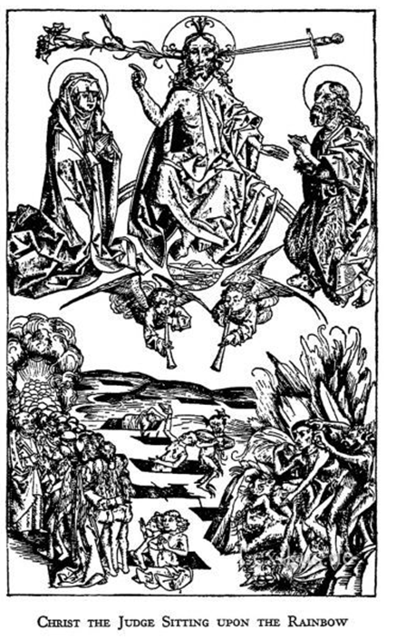

This is an image from a wood carving done around this time that shows Christ sitting on a rainbow in judgement, with a lily protruding from one ear, and a sword from the other. Below the devil is dragging someone by the hair, down into the pits of hell. Luther is tormented by images like this one. He is acutely aware that his sin separates him from God.

A year after Luther entered the cloister, he had another crisis moment, when conducting his first mass. Luther was reciting the mass and he came to the words “we offer unto thee, the living, the true, the eternal God.” And Luther says,
At these words I was utterly stupefied and terror stricken. I thought to myself, “With what tongue shall I address such Majesty, seeing that all men ought to tremble in the presence of even an earthly prince? Who am I, that I should lift up mine eyes or raise my hands to the divine Majesty? The angels surround him. At his nod the earth trembles. And shall I, a miserable little pigmy, say, ‘I want this, I ask for that’? For I am dust and ashes and full of sin, and I am speaking to the living, eternal, and the true God.”

How could man abide God’s presence unless he were holy? Luther pursued holiness in all of the ways that the Church said that he should, but never felt confident that he was safe from God’s wrath.

Indulgences:
We need to talk for minute now about a doctrine of the church that later served as the spark that lit a fire under Luther, which is the selling of indulgences. An indulgence is essentially a piece of paper that buys you a certain number of years off of your time in purgatory. Purgatory is the halfway house, the place where you go to achieve the holiness that is necessary to enter into heaven. The works of righteousness that we mentioned a minute ago count on your behalf, and the sum total of them determines the length of your sentence, but all souls could expect to spend some time in Purgatory before being admitted into paradise. The church taught that Jesus and Mary were holier than they needed to be, and so earned an excess of merit. They created a repository of righteousness, from which the Pope could draw, and distribute, to reduce one’s time in purgatory.

The Pope at this time was Leo X, and Leo had rather expensive tastes. He had some important projects under way that needed financing, particularly St Peter’s basilica in Rome. One of the primary ways that the church financed these endeavors was through the selling of these indulgences. An indulgence could be procured for yourself or for a relative in exchange for a financial contribution to the church’s treasury.
There was a man named Tetzel who was an infamous peddler of indulgences. He had a little ditty that he would sing as he passed through the streets, “as soon as coin in the coffer rings, a soul from purgatory springs.”

The other way you could acquire merit for yourself, and incidentally, another source of revenue for the church, was by visiting relics. The church supposedly had in its possession, among other things, branches from the burning bush, the chains of St. Paul, a strand from the baby Jesus’ swaddling clothes, and even a thorn from his very crown. There were thousands more. One could pay a fee to observe these relics and by so doing, earn time off of your sentence.

In 1510, Luther visited Rome, and on this trip the scales started to fall from his eyes with regard to some of these claims of the Church. He had gone with the intention of taking advantage of these opportunities, but he came back with a sour taste in his mouth. He was appalled at the corruption and abuse that he saw there. “Who knows whether it is so,” he said when he returned, with regards to the Church’s claims about relics and indulgences.

Wittenburg:
In 1511, Luther was transferred from Erfurt to Wittenberg, where he became a professor at the university that was created by Frederick the Wise. The vicar of the Augustinian order was a man named Johann von Staupitz. Staupitz would become a mentor for Luther at a critical time. Luther later said, dramatically, but perhaps rightly, “If it had not been for Dr. Staupitz, I should have sunk in Hell.”

In Wittenberg, Luther’s spiritual crisis continued to grow. He confessed his sins every day, on occasion up to six hours in a day. But he always remembered more. His fellow monks began to grow tired of Luther’s incessant confession of these petty little sins. Once Dr. Staupitz chided him, “If you’re going to spend so much time at the confessional, go out and commit a real sin, like murder.”
During this time of spiritual turmoil Luther came to realize that man’s very nature is corrupt. He was at an impasse. Sins must be confessed to be forgiven, but he doesn’t always even recognize when a sin has been committed. Staupitz tried to encourage him that “all that is required is to love God,” but how can you love a God who is a consuming fire; a Christ who sits on a rainbow throne raining down judgement on those who harbor unconfessed sin?

In a bit of a risky move, Dr. Staupitz asked Luther, this conflicted monk, to take up preaching and assume the chair of Bible at the university. This move proves to be the catalyst for Luther’s great spiritual awakening. Luther was tormented by questions about how a sinful man could be reconciled to the holy God, and the church had no remedy to offer. He found his answer in the pages of the Bible.

In 1513, Luther began to study and preach through the Psalms. Over the next few years, he preached through Galatians and then Romans as well.

Luther had a Christological reading of the Old Testament, so when he came to Psalm 22, “My God, my God, why hast thou forsaken me,” he thought of Christ on the cross, and he was struck that Christ experienced his anguish. But how could that be so if he was righteous? It could only be if Christ took on the iniquity of us all. So now a new vision of Christ started to take shape. Not angry, but loving. Not only one who sits above in judgement, but one who sympathizes with our weakness.

Tower experience:
But Luther’s most dramatic encounter with the gospel in scripture came in what is known as his “tower experience.” Reflecting on it later in his life, Luther placed it in 1519, but there is some debate about when it actually happened. In any case, here is Luther’s own account:

Meanwhile in that same year, 1519, I had begun interpreting the Psalms once again. I felt confident that I was now more experienced, since I had dealt in university courses with St. Paul's Letters to the Romans, to the Galatians, and the Letter to the Hebrews. I had conceived a burning desire to understand what Paul meant in his Letter to the Romans, but thus far there had stood in my way, not the cold blood around my heart, but that one word which is in chapter one: "The righteousness of God is revealed in it." I hated that word, "righteousness of God," which, by the use and custom of all my teachers, I had been taught to understand philosophically as referring to formal or active righteousness, as they call it, i.e., that righteousness by which God is righteous and by which he punishes the unrighteous sinner.
But I, blameless monk that I was, felt that before God I was a sinner with an extremely troubled conscience. I couldn't be sure that God was appeased by my satisfaction. I did not love, no, rather I hated the righteous God who punishes sinners. In silence, if I did not blaspheme, then certainly I grumbled vehemently and got angry at God. I said, "Isn't it enough that we miserable sinners, lost for all eternity because of original sin, are oppressed by every kind of calamity through the Ten Commandments? Why does God heap sorrow upon sorrow through the Gospel and through the Gospel threaten us with his righteousness and his wrath?" This was how I was raging with wild and disturbed conscience. I constantly badgered St. Paul about that spot in Romans 1 and anxiously wanted to know what he meant.
I meditated night and day on those words until at last, by the mercy of God, I paid attention to their context: "The righteousness of God is revealed in it, as it is written: 'The righteous person lives by faith.'" I began to understand that in this verse the righteousness of God is that by which the righteous person lives by a gift of God, that is by faith. I began to understand that this verse means that the righteousness of God is revealed through the Gospel, but it is a passive righteousness, i.e. that by which the merciful God justifies us by faith, as it is written: "The just person lives by faith." All at once I felt that I had been born again and entered into paradise itself through open gates. Immediately I saw the whole of Scripture in a different light. I ran through the Scriptures from memory and found that other terms had analogous meanings, e.g., the work of God, that is, what God works in us; the power of God, by which he makes us powerful; the wisdom of God, by which he makes us wise; the strength of God, the salvation of God, the glory of God.
I exalted this sweetest word of mine, "the righteousness of God," with as much love as before I had hated it with hate. This phrase of Paul was for me the very gate of paradise.”

And mark here just how central a figure Augustine was to Martin Luther. This is what he said next:

“Afterward I read Augustine's "On the Spirit and the Letter," in which I found what I had not dared hope for. I discovered that he too interpreted "the righteousness of God" in a similar way, namely, as that with which God clothes us when he justifies us.”

Luther wrote this account toward the end of his life, some 25 years later. The dramatic telling gives the impression that his realization was another coup de foudre, like the one that first sent him into the monastery. But in reality it was the culmination of years of progressive revelation, rooted in daily exploration of the scriptures. Luther found the answer to his spiritual crises in the pages of the Bible, through the performance of his daily task. These are ideas that we’ll discuss more later.

What Luther had discovered was the gospel. Justification by faith is at the heart of the good news. It means that our standing before God doesn’t depend on our own ability to do the very best that is within us. It is a gift of God. The work that is required was accomplished by Christ. We need only trust in Him. We’ll come back to this later, but suffice it to say for now that this discovery was totally emancipating for Luther. It was medicine for his soul.

95 Theses:
In 1517 another scandal erupted. Prince Albert, a powerful bishop, who aspired to even greater power, haggled with the Pope and essentially arranged to buy the archbishopric of Mainz. The Pope then, as a gesture of goodwill, granted Albert the privilege of recouping his expense by offering an indulgence in his territory.

So imagine the situation. Tetzel and Albert are pillaging the German countryside, spiritually, and in some ways literally through their selling of indulgences, and Luther is now a preacher with responsibility for his own flock at the Castle Church in Wittenberg. His own spiritual reformation is underway, and by now he flatly rejects the practice of selling indulgences. Luther does not believe that the Pope has the authority to remove punishment for sin. He believes that only God has that authority.

So Luther did something that would turn out to be monumental, but at the time was not at all unusual. He proposed a debate. And he did this by posting a set of theses on the church door in Wittenberg. The date was October 31, 1517. If you only remember one date from tonight, let it be this one. It is the one most commonly cited as the beginning of the Protestant Reformation. Next year we will celebrate the 500th anniversary of the event. Luther’s theses that he is offering up for debate are primarily on the subject of indulgences. To the modern reader they don’t make a great deal of sense unless you know the context. They centered on the use of indulgences to fund the construction of St. Peter’s, and a denial of the Pope’s power over purgatory. This is happening before Luther’s ideas about justification by faith have fully taken form.

In retrospect, we know the significance of what Luther was doing, but revolution was not his aim. Bainton, quoting Karl Barth, says of Luther’s experience, “He was like a man climbing in the darkness a winding staircase in the steeple of an ancient cathedral. In the blackness he reached out to steady himself, and his hand laid hold of a rope. He was startled to hear the clanging of a bell.”

Luther did not distribute the theses, but others took them, translated them, and began to circulate them around town. In short order Luther’s theses became the talk of Germany. This was the spark, but clearly the tender was stacked and dry. The fact that the thesis were surreptitiously distributed shows that there was brooding unrest and disapproval of some of the practices of the Church.

Trouble with the Church:
At this point things started to progress quickly. Luther sent a copy of the theses to Prince Albert, along with a letter complaining about Tetzel’s hawking of indulgences. Albert then forwarded the theses on the Pope. Now Luther was in the crosshairs, so to speak. The pope tried a clandestine approach to getting Luther under control, by allowing the Augustinian order to try to sort it out as a local matter. That proved to be a fatal mistake. A few months later, at a meeting in Heidelberg, Luther was given a chance to expand on his 95 theses. This is known as the Heidelberg Disputation. Martin Bucer, another important reformer, was in attendance and heard Luther’s ideas for the first time. His fame spread as he continued to preach and teach against the corrupt practices of the church, and within less than a year of the posting of the 95 theses, Luther was summoned to Rome for a trial.

Luther had good reason to be wary about a trial in Rome. The church did not take this sort of insubordination lightly. A hundred years earlier, John Huss had been similarly summoned to Rome and even guaranteed safe conduct. Upon his arrival he was quickly tried and burned at the stake.

With the support of Frederick the Wise, Luther managed to get the trial delayed, and eventually transferred from Rome to Germany, where he felt much less threatened. A word about Frederick the Wise - there would be several times in Luther’s life when Frederick would serve as Luther’s protector. He was not a full throated supporter, at least at first. In fact, he considered himself faithful to the Pope. But he was reluctant to hand Luther over until he was fully convinced that he was, in fact, guilty of the heresy that we has being accused of. To Frederick it was an open question, and he knew Luther’s likely fate if the Pope got hold of him. The pope called on Frederick to banish Luther from his territory, but Frederick refused to do so.

At this point Luther’s boldness and conviction were growing, and his disdain for the Pope was growing as well. Not only can the Pope err, he says, contrary to Church teaching, but Luther felt and said, in all seriousness, that the Pope was in fact an antichrist, because of the way that the Church was misleading people about the nature of salvation. You can image how that was received.

In 1518, waiting for the details of his trial to be sorted, Luther had a famous debate with a theologian named John Eck, known as the Leipzig debate. There Luther declared that “a simple layman, armed with scripture, is to be believed above a pope or a council without it.” After the debate with Eck, word of Luther’s teaching spreads even further, and his fame becomes international. At this point it could be said that Luther was the head of an international movement. Although you still get the impression that he was just following his conscience, that he would have behaved exactly the same if no one knew his name.

In 1519-20, Luther wrote a series of pamphlets that, thanks to the printing press, were widely distributed.

“The Address to the Christian Nobility” is where he introduces the idea of the priesthood of all believers. “It is the ministry of the Word that makes the priest and the bishop.” He argues that it is the work of all christians, through their own vocational roles, to participate in this ministry of the Word. There is no status distinction between priests and laymen.

The second treatise is called “The Babylonian Captivity of the Church.” In this one, Luther rewrites some key church doctrines on the sacraments. At this time the church had seven sacraments. In addition to baptism and the Lord’s supper, they also included confirmation, penance, ordination, marriage, and last rights. Luther whittled these down to just the two that we know today, arguing that a Christian sacrament must be uniquely Christian, and ordained by Christ himself.

On the baptism and the Lord’s Supper, Luther’s views were different than ours. He remained a paedobaptist even after he had split with the Church’s teachings in so many other area. This was a topic of debate later on with rise of the Anabaptists, but while we practice believer’s baptism, it’s true that the reformers that we love were all paedobaptists.

The Lord’s Supper, on the other hand, was an area of some disagreement among the reformers. Phil alluded to this in his talk last time. The Church at the time taught, and Catholics still believe today, what is known as transubstantiation. What this means is that they believe that when the bread and the wine are consecrated, their substance changes and they become, literally in substance, the body and blood of Christ. They still have the form of bread and wine, but in essence they are the body and blood of Christ. The eucharist, for them, is a repeated sacrifice. Christ is re-sacrificed every time we take the Lord’s Supper. The reformers rejected this, but to varying degrees.

Huldrych Zwingli represented what’s called the memorial view. That is that the bread and wine only symbolically represent the body and blood.

Luther’s view was in between. He rejected the idea that the eucharist was a propitiatory sacrifice. He held that the substance of the bread and the Lord’s body are present together, and so his view is sometimes called Consubstantiation. He was not very interested in trying to explain how this all worked. It was to be accepted on faith. What was important for him was that Christ was really present in the Lord’s Supper, full stop. Transubstantiation to him was an Aristotelian invention meant to explain away a mystery. But Luther was unwilling to abandon the idea that Christ was really present in the elements, in some mysterious way.

John Calvin’s view was perhaps somewhere between that of Luther and Zwingli. He held, essentially, that the Lord’s Supper is symbolic, but he viewed symbol differently than some of us are used to. To him, in God’s economy, the symbol and the thing symbolized are so connected that what is true of one can be said of the other. We don’t really have time to get into that, and I wouldn’t be prepared to, even if we did. But I think there are some in our church who would align themselves with Calvin on this question.

The third treatise is called “On the Freedom of a Christian.” It is a wonderful, beautifully written little book that defends justification by faith, and its implications on Christian love and liberty. His thesis is that the Christian is simultaneously the “most free lord of all, and subject to none,” and “the most dutiful servant of all, and subject to everyone.”

Getting back to the story, in 1520 the papal bull was finally issued that formally excommunicated Luther from the Church. The Pope said, “A wild boar has entered thy vineyard.” Luther’s books were publicly burned in a symbolic display. So when a copy of the bull finally reached him, he and his supporters responded by burning the bull.

Diet of Worms:
The bull gave Luther 60 days to report to Rome for his trial. Luther, now really feeling the pressure, wrote directly to Emperor Charles and appealed to have his case heard before a secular tribunal, rather than before the Pope who already presumed him guilty. This was another tense moment. Again, Luther’s strongest advocate was Frederick the Wise. Emperor Charles, on the advice of Frederick, and also with mounting public pressure, invited Luther to a hearing to be held at Worms. There Luther’s case would be heard by the emperor himself.

In April of 1521, Luther arrives at Worms in a two wheeled cart. This was real drama, and is the climactic moment of this story. Roland Bainton describes the scene like this:

Here was Charles, heir of a long line of Catholic sovereigns – of Maximilian the Romantic, of Ferdinand the Catholic, of Isabella the Orthodox – scion of the house of Hapsburg, lord of Austria, Burgundy, the Low Countries, Spain, and Naples, Holy Roman Emperor, ruling over a vaster domain than any save Charlemagne, symbol of the medieval unities, incarnation of a glorious if vanishing heritage; and here before him a simple monk, a miner’s son, with nothing to sustain him save his own faith in the Word of God. Here the past and the future were met. Some would see at this point the beginning of modern times. The contrast is real enough. Luther himself was sensible of it in a measure. He was well aware that he had not been reared as the son of Pharaoh’s daughter, but what overpowered him was not so much that he stood in the presence of the emperor as this, that he and the emperor alike were called upon to answer before Almighty God. (HIS)

In the room was a table piled high with Luther’s books, and he was asked flatly to recant what he had written. The weight of the moment was not lost on Luther. He hesitated and asked for a recess. The Emperor granted him a recess, then the next day he was pressed again, “Martin Luther, will you recant what you have written?” Finally he gathered his courage and responded, famously,

“Since your majesty and your lordships desire a simple reply, I will answer without horns and without teeth. Unless I am convicted by scripture and plain reason - I do not accept the authority of popes and councils, for they have contradicted each other - my conscience is captive to the Word of God. I cannot and I will not recant anything, for to go against conscience is neither right nor safe. Here I stand, I can do no other. God help me.”

The verdict of Prince Charles and the diet was that Luther was indeed a heretic, and so Luther was forced to flee into exile for his own safety. Frederick the Wise once again came to his aid and arranged to hide him away in the Wartburg castle. There Luther would remain for nearly a year.

Reform Spreads:
After the diet of Worms, the Reformation train had crested the hill. Luther continued to be a central, authoritative figure, but his role changed from one of opposition to a more constructive role, holding what ground had been gained, and prescribing what church life should look like apart from the traditions of the Roman Church.

While Luther was in exile, the reformation continued to spread and take on a life of its own. “The Word did it all,” he said. “Had I wished I might have started a conflagration at Worms. But while I sat still and drank beer with Philip and Amsdorf, God dealt the papacy a mighty blow.”

This is true. But without Luther’s commanding presence, the reformation project in Wittenberg started to spin out of control. In some cases violence broke out. There were influential men who had their own ideas about what Reformation should look like. These were men like Thomas Muntzer, and a group of three men who called themselves the Zwickau prophets. The Zwickau prophets showed up in Wittenberg while Luther was away. They claimed that they had no need for the Bible, but instead relied entirely on the Spirit. Muntzer and the Zwickau prophets wanted to usher in the new kingdom of heaven through the “slaughter the ungodly.” Luther, for his part, wanted no part in the violence and encouraged the magistrates to bring it under control.

Philip Melanchthon, Luther’s close friend and ali, was leading the effort in Wittenberg in Luther’s absence, but the ideas of these false teachers were gaining traction. Finally, in March of 1522, Luther left the protection of Wartburg and returned to Wittenberg, at great risk to himself. This was really one of Luther’s bravest moments. His life was very much at risk. But Luther was indeed a stalwart presence, and he was successful in restoring some order in Wittenberg. Some people even point to this moment, Luther’s return to Wittenberg, as, strictly speaking, the beginning of the Reformation, because this was when Luther began prescribing specific reforms to the doctrine and practice of the Church. But the date is academic. These were the events, in the life of Martin Luther, anyway, that sparked the Reformation of the Church. It’s important to remember that the Reformation was a massive, complicated movement. There were other men like Huldrych Zwingli, in Switzerland who were contemporaries of Luther and were working to reform the church, largely independent of what Luther was doing. But none of them matched Martin Luther in stature or significance. The story of the Protestant Reformation really has this man at its center.

Marriage:
We’ll transition in a minute to talk more about Luther’s theological legacy, but first we’re going to quickly breeze over the last 25 years of his life. Several noteworthy things happened around the year 1525.

One of the immediate social effects of the Reformation was that men began to leave the monasteries, and women, likewise began to flee the convents. These women who had left the convent were in need of husbands, and Luther often took it upon himself to play the role of matchmaker and find these women husbands. When Luther was 42 years old, one such group of 12 nuns came into Wittenberg. After Luther had successfully found situations for 11 of the ladies, there remained one Katherine Von Bora. Now Luther was not personally enamored with the idea of marriage, but he saw it as a way to put his money where his mouth was, so to speak. He had spoken out against the catholic requirement of celibacy on the part of priests, and Luther came to think that it would be appropriate for him to marry. In Luther’s mind, marriage displaced the monastery. He called it a “school for character.” Katherine had made it clear that she considered Martin a suitable choice, and Luther agreed to marry her. Katherine was by all accounts a very industrious woman. In addition to keeping the household, she farmed, butchered, doctored the family, and even brewed beer. And though Luther did not marry for love, he did come to love her dearly. Some of his letters to her are a delight to read.
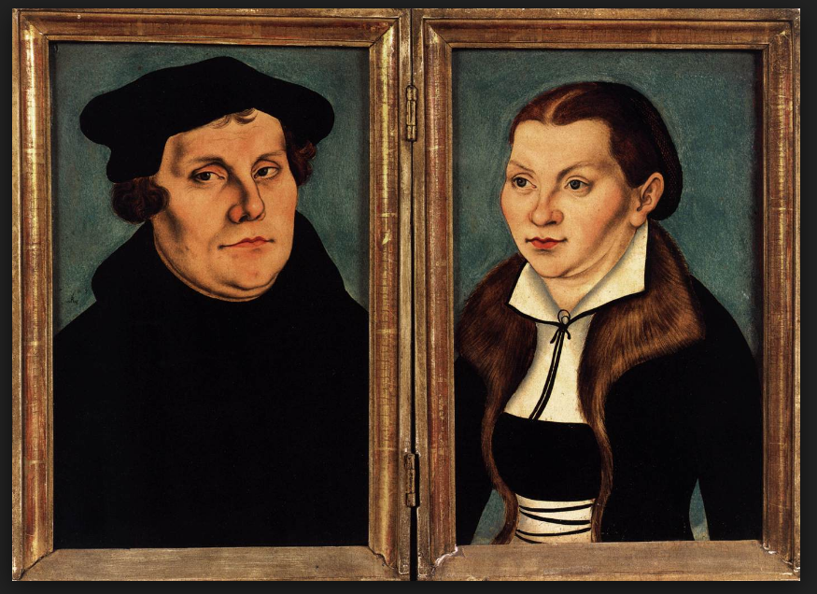

Bondage of the Will:
That same year Luther published one of his most well-known book, The Bondage of the Will. J.I. Packer called it “the greatest piece of theological writing to ever come from Luther’s pen.” And Luther agreed. Looking back on his complete oeuvre, Luther reflected that of all of his writings, he would be content of only his children’s catechism and The Bondage of the Will were preserved. It has, in fact, been regarded as a sort of manifesto of the Reformation. He wrote it in response to a book called Freedom of the Will, written by Erasmus. Erasmus was an enormously important figure, even for Luther. His Greek New Testament was the text that Luther used for his study of Paul that we discussed earlier. The issue being debated here was not whether man’s actions were free in the sense of having an ability to make meaningful, spontaneous choices. It was a gospel issue. Luther understood the “bondage of the will” to mean man’s inability to lift himself out of sin, and God’s gracious sovereignty in salvation. Man has no ability to please God. All he can do is keep on sinning. And man must come to understand that he is a slave to sin before he can come to God for freedom and salvation. That’s why this was such a critical issue for Luther. You also get a good taste for Luther’s delightfully confrontational tone in this book. He pulls no punches in his interaction with Erasmus.

Peasant’s War & Writings on the Jews:
There are a couple of things that we should mention that have drawn Luther criticism, some of it justified. He is often criticized for his response to what is called the Peasant’s War that broke out about this same time. When large numbers of peasants revolted and violence broke out, Luther came out against the Peasants, and quite viscously so. He wrote a tract called “Against the Murderous and Thieving Hordes of Peasants.” He encouraged the magistrates to put down the rebellion by whatever means necessary, and that’s exactly what they did. Thousands of peasants were killed.

But one of the most common criticisms that you’ll hear about Luther has to do with his late writings on the Jews. He wrote a rather vulgar tract, advocating that all Jews be deported to Palestine and they be forced to live off the land. His defenders will say, perhaps rightly, that Luther’s criticisms of the Jews was entirely religious in nature, and not racial. He reckoned that the Jews had rejected Christ, and when he learned that certain Christians were converting to Judaism, he reacted angrily.

It’s undoubtedly true that Luther became ornery in his old age. His language became more vulgar, more angry. And we are certainly under no compulsion to embrace everything that he wrote. Wouldn’t Luther, himself, have wholeheartedly agreed? No man is infallible, Pope or peasant. God uses men and women for his purposes, and to reveal his truth as he sees fit. Luther’s writing is not scripture, and he was first in line to say so. God’s word, is our only reliable guide.

Bible Translation & Preaching:
On that note, and turning back to his more positive legacy, while Luther was in exile in Wartburg after the Diet of Worms, he began a translation of the Bible into German. In only three months he had completed a translation of the entire New Testament. Later in his life he completed the Old Testament as well, and he continued to revise his translation all the way up until his death. His translation was the one most commonly found in German households of the day, and was a very important work.

The reformation also brought the Word back to the center of Christian worship, and by implication, the preaching of the Word. Luther himself was a prolific preacher, sometimes preaching multiple sermons a day. Many of his sermons were recorded by his students and are still available for us to read today.

Death:
Martin Luther died in 1546, at the age of 62. His help had been requested in Mansfeld to mediate a dispute. He was old and ill, but he went, and died on the way back home. He died, somewhat ironically, in Eisleben, the city where he was born.

Doctrine:
Let’s turn now to discuss Luther’s theological significance. Luther was certainly a large personality and he sometimes had a mouth to fit, but he was also a theologian of the first order. He was not the exegete and systematizer that Calvin would be a generation later, but who was? Luther should not be shorted as a thinker and theologian. I have certainly not read everything that he wrote, but in what I have, I find a coherence and consistency to his thinking. Everything comes back to justification by grace, through faith. You do, with Luther, perhaps more than most, have to take into account which Luther you’re reading. Luther’s thought changed dramatically over the course of his pilgrimage from a good Catholic monk to the champion of the reformation. So the theology that you get in the 95 theses, for instance, still contains a lot of residue from his upbringing, and shows only a glimpse of the full throated defense of the doctrines of grace that you’ll get in his commentary on Galatians, written later in his life.

The theology of the Reformation is often summed up in what is known as the five solas.

Sola Fide - Salvation is by faith alone, and not by any works of our own.
Sola Gratia - It is by God’s grace alone, and not due to anything that we have merited
Sola Scriptura - God’s word is our only reliable guide and source of ultimate knowledge
Sola Christus - It is only through Christ’s atoning work that we have salvation
Sola Deo Gloria - All for God’s glory, and not our own

Justification by Faith:
The most significant of Luther’s contributions has to be his role in the recovery of the doctrine of justification by grace through faith. The good news of the gospel is that God sent his Son into the world to die to save sinners. The Roman Church taught that God infuses us with righteousness and then we merit our salvation through works that we do in cooperation with God’s grace. But justification by faith simply means that the way our sins are forgiven - the way we are made right with God - is only by receiving what He has done, and not by bringing anything of our own.

The righteousness that is ours is an “alien righteousness” - meaning it exists outside of us. And that righteousness comes to us through faith alone. Faith means trusting in the finished work of Christ on our behalf. One commenter said that “The great reformation truth is that God looks on us as righteous, regardless of the state of our life.” Luther called the righteousness that we possess a “passive righteousness,” as opposed to an active righteousness. He meant simply that the righteousness that we have before God is received, it is not merited by any work that we do. This doctrine is central to the gospel, and it was central for Luther. Everything else that he said stemmed from this truth.

His commentary on Galatians has probably his most thorough and mature defense the doctrine. Here is a sample quote from his introduction. Speaking about the “passive righteousness” that I mentioned:

Do we work nothing for the obtaining of this righteousness? I answer: Nothing at all. For the nature of this righteousness is, to do nothing, to hear nothing, to know nothing whatsoever of the law or of works, but to know and to believe this only, that Christ is gone to the Father and is not now seen; that he sitteth in heaven at the right hand of his Father, not as a judge, but made unto us of God, wisdom, righteousness, holiness and redemption; briefly, that he is our high priest entreating for us, and reigning over us and in us by grace.

The first half of his Treatise on Christian Liberty also contains a beautiful defense of justification by faith. A sample from that treatise:

If you were nothing but good works from the soles of your feet to the crown of your head, you would not be worshipping God, nor fulfilling the First Commandment, since it is impossible to worship God without ascribing to Him the glory of truth and of universal goodness, as it ought in truth to be ascribed. Now this is not done by works, but only by faith of heart. It is not by working, but by believing, that we glorify God, and confess Him to be true. On this ground faith alone is the righteousness of a Christian man, and the fulfilling of all the commandments.

Centrality of the Scriptures:
Luther also fought to restore the centrality of the Word of God to the Christian’s life. “One thing, and one alone is necessary for life, justification, and Christian liberty; and that is the most holy Word of God.” He insisted that the Scriptures were the only reliable guide for the Christian, and the only dependable source of truth. Remember what he said at the Leipzig debate, “a simple layman, armed with scripture, is to be believed above a pope or a council without it.” And at the diet of Worms, he insisted that unless he were convicted by scripture, he would not recant anything that he had said. And of course it was through his study of the scriptures that God revealed to him the gospel truth.

In some ways this was the thing that got him in trouble with the Roman Church. They didn’t appreciate his stance on indulgences, but he also rejected the Church’s claim that the Pope held on monopoly on the interpretation of scripture, and he insisted that the Pope was a man who could err like any other man. Only the scriptures were an infallible source of truth.

The importance of this really can’t be overstated. I said before that justification by faith was his greatest contribution, but that is really inseparable from his reverence for the Word of God. The two go hand in hand.

On Freedom, Love & Vocation:
Some of my favorite of Luther’s writing are on the ideas of Christian freedom, Christian love, and a Christian’s vocation, which for Luther are all intertwined.

All of this is born out of the doctrine of justification by faith. Luther had experienced the bondage that comes from trying to earn your salvation through works of penance. But the Christian is not bound to agonize over every jot and tiddle of the law. His salvation is accomplished - it’s done - and it comes to us only through the instrument of faith.

The freedom that the Christian enjoys is freedom from the bondage of sin and the law. It is freedom from the unbearable burden of trying to earn your salvation through perfect obedience. The Christian enjoys freedom from sin and the law, and freedom to serve his neighbor in whatever way the situation calls for. Here is a passage from his treatise on Christian Liberty.

“Yet a Christian has need of none of these [good works] for justification and salvation, but in all his works he ought to entertain this view and look only to this object – that he may serve and be useful to others in all that he does; having nothing before his eyes but the necessities and the advantage of his neighbor. Thus the Apostle commands us to work with our hands, that we may have to give to those in need. He might have said, that we may support ourselves; but he tells us to give to those that need. It is the part of a Christian to take care of his own body for the very purpose that, by its soundness and well-being, he may be enabled to labor, and to acquire and preserve property, for the aid of those who are in want, that thus the stronger member may serve the weaker member, and we may be children of God, thoughtful and busy one for another, bearing one another’s burdens, and so fulfilling the law of Christ. Here is the truly Christian life, here is faith really working by love, when a man applies himself with joy and love to the works of that freest servitude in which he serves others voluntarily and for naught, himself abundantly satisfied in the fullness and riches of his own faith.” (Christian Liberty, pp 57-58)

What binds the Christian is not the law, but only the needs of his neighbor. And this is not for the sake of your salvation, but as the overflow of God’s love toward you, into the lives of those around you.

The good things which we have from God ought to flow from one to another and become common to all, so that every one of us may, as it were, put on his neighbor, and so behave toward him as if he were himself in his place. They flowed and do flow from Christ to us … From us they flow to those who have need of them.

For Luther, The most basic way that a Christian does this is through the faithful performance of the daily tasks that make up our various vocations. Vocation is a broad term that includes each of the roles that God has called you to. Engineer, lawyer, electrician, husband, wife, father, mother, churchman, etc. Each of these are callings on your life, and each of them has associated tasks that are conduits through which the grace of God flows into the life of your family and neighbor. These are the masks of God. God’s free and undeserved love is behind your vocational service to your neighbor, giving it power, and bringing about his purpose.

I would love to talk all night about Luther on loving your neighbor, but we can’t. I’ll just recommend two books. The first is called Luther on Vocation, by Gustaf Wingren. He have this in the church library, so you can check it out for free. It’s a bit expensive to buy. It’s a thick read, but it will change your life, and I mean that in all seriousness. The second is Gene Veith’s God at Work, which is largely based on Wingren’s book, but is shorter and more manageable. We also carry this one in the bookstore, and it is also very good.

While I’m commending books, there are loads of biographies out there on Martin Luther. The one that I have and can recommend is Roland Bainton’s Here I Stand. It’s probably the most commonly recommended one out there right now. It’s very readable, admiring, but not overly hagiographic. I have a few copies in the bookstore that you can purchase on Sunday if you like.

As far as Luther’s writing, his treatise on Christian Liberty is a great place to start. And after that, the Bondage of the Will would be best place to get a summary of his thought. Lot’s of people also love his Galatians commentary.

There’s so much more that we could talk about. We could spend an entire evening talking about Luther’s love of music, and his thoughts on music in the church. He was more of a mind with us than were some of the other reformers. But that’s all that we have time for tonight.

